**CSE 115 – Introduction to Software Engineering**

**Sprint PlanTemplate**

The team needs to capture the result of their sprint planning meeting in a document with the structure outlined below. This document (as well as other project documents should be made accessible to the team’s TA (e.g., via shared Google docs or drive).

There is no further submission process. All project documents are created for the benefit of

your project and team, not the entertainment of the teaching staff.

**Heading:** Sprint 2 plan, World of Feel Well, FeelWell, Due 7/15/2024, (revision number & revision date)

**Goal:** finish ⅗ of the MVP. Specifically the database, UI of all the pages, and log in.

**Task listing, organized by user story:** This section lists the user stories, in priority order from

∙

most important (top) to least important (bottom). Within each user story, there needs to be a list of tasks required to implement the user story, along with the time estimate for each tasks (preferably less than or equal to 6 ideal hours). This should look like:

* {1}As a player, I want to be able to log in to my account to save my progress. [13]
  + Login screen (4-6 Hours)
    - Login UI (2-3)
    - User authentication (2-3)
  + Working with Database (5-6 Hours)
    - Create User (2-3)
    - Update Values (2-3)
* {3}As a player, I want to have daily/weekly “quests” that I can work towards if I choose to. [13]
  + User Interface (6-10 Hours)
    - Layout
    - sprites
      * Logo (1 Hour)
      * Badges (1 Hour)
      * Progress (1 Hour)
      * Banner background (1 Hour)
      * Avatars (2-3 Hours)
  + Gameplay (8 Hours)
    - Check off task -> update schedule, progress bar, progress toward
      * Words of Affirmation (2 Hours)
      * Protein Goal (2 Hours)
      * Hit Gym (2 Hours)
      * Step Goal (2 Hours)
* {4}As a player, I want to have a customizable profile that is visible to other users displaying my accomplishments with certain badges and awards [8]
  + UI (2 Hours)
  + XP Progress - overall points (2 Hours)
  + Health - consistency (2 Hours)

**Team roles:** Give a listing of all team members. Next to the team member, list their role(s) for

∙

this sprint. Assign each person to at least one role (for example, this role might be "Developer"). This looks like:

Aidan Adair: Scrum Master/Developer

Harry Dole: Product Owner/Developer

Kevin Tran: Developer

Julian Chop: Scrum Master/Developer

Erick Hernandez: Developer

∙ **Initial task assignment:** A listing of each team member, with their first user story and task assignment. This should look like:

Aidan Adair: {3}, Quests Layout, progress bar

Harry Dole: {1}, Create User

Kevin Tran {4} : Health Bar

Julian Chop: log-in UI

Erick Hernandez: {1}, Update Values

∙ **Initial burnup chart:** A graph giving the initial burnup chart for this sprint and is labeled as such

with sprint number and project name and is located in the lab.

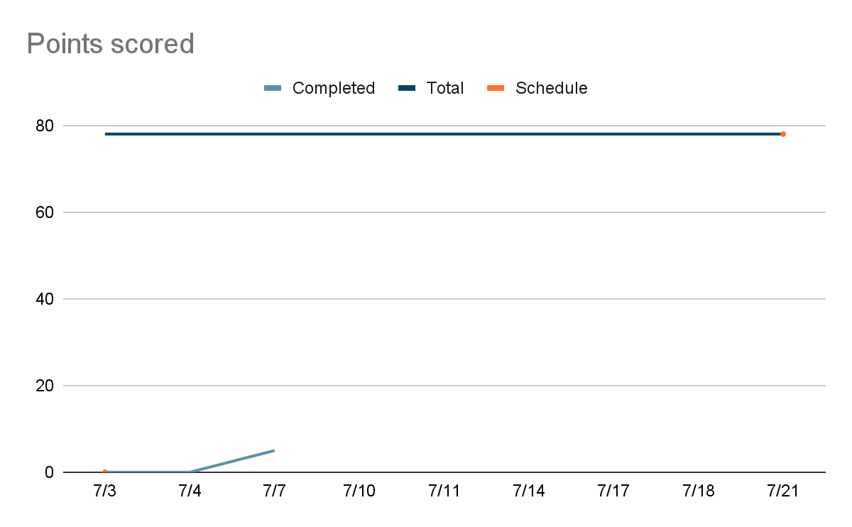

**Initial scrum board:** <https://trello.com/b/AmTWVAyh/feelwell-team>

**Scrum times:**

M: 3:30pm

W: 6:00pm

F: 3:30pm

Note that if the team ended up modifying its release plan during sprint planning, submit an updated release plan document also with the sprint plan.

Last modified: 2023 06 25 (adapted from materials for cmps115)